Task walkthroughs



Committee on Committees Vice Chair

Transition Report
By Fall/Winter 2025-26 Vice Chair

LETTER
Mic check… Is this thing on? Hello new Vice Chair! This is your lovely, amazing, super cool 2025 Fall/Winter Vice Chair Shuyi 😜~

Honestly, I joined CoC (and AS) for the first time as a 4th year with no idea what AS was about. Turns out there’s a lot going on in this little Schrödinger box. But be not afraid, for I have written down how to run this shit like the Navy (in a much less dramatic sense irl).

The Vice Chair position is a little peculiar in the sense that you have to know how to do the Internal Chair, External Chair, and everyone else’s job in order to do yours. So my first piece of advice? Read everyone else’s transition reports. My other big piece of advice: keep your team together. This isn’t something to find in the Legal Code or be ticked off on a to-do list, but I noticed during my time as VC that this was sometimes my most important task - so get to know your board members, crack some jokes in the group chat, and keep the energy up during meetings!

Okay, that’s all I can think of… Reach out if you have any questions (after you reach out to your Chairs, first).

P.S. This is a great position to put down experience for administrative, management, legal, and secretarial opportunities, so try to take on or make new tasks for yourself!

SETUP
- Update the email signature with your name !!
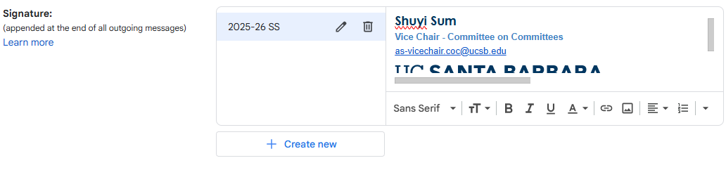
- Update the 2-Step Verification with your number !!
→ Manage Google Account
→ Security
→ 2-Step Verification Phones
(510) 502-4064, shuyi.sum@gmail.com
- Reach out if having trouble logging in !

Overview of main duties (Legal Code)
(but only the important ones, really)
- Assume the duties of the Chairpeople when they are absent or as designated (aka familiarize yourself with Internal and External Chairs’ duties)
- Track meeting attendance, maintain meeting minutes
- Schedule, advertise, and attend interviews of applicants for A.S. Committee positions (when needed) and student representative positions on Academic Senate and Administrative Advisory Committees.
  - Coordinate the scheduling of all interviews (see below)
- Ensure that all Candidates are informed of their acceptance or rejection, and maintain a record of who accepts and who declines. (see below)
- Maintain an accurate list of vacant positions on the Committee on Committees website.
  - See Website SOP

DAILY/WEEKLY TASKS
The following tasks are related to the day-to-day operations of CoC and are mainly very simple, remote things to remember to do whenever you’re available.

→ Check email for applicants
- Look in vice chair email for applicants and put them in the Candidates spreadsheet
(looks like this:
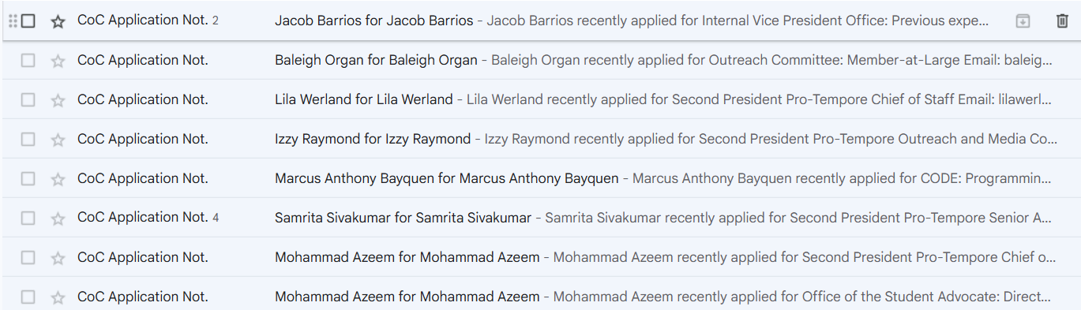
- Check Shared Drives → CoC → find the current spreadsheet for the academic year
  - Or make a copy of previous year’s:
2025-2026 Candidates
- Move all applications to the “Applications 202X-2X” label in the Gmail
  - Keeps things organized + you may need to pull numbers/stats for our quarterly report (ex: we received # applications across # BCUs and conducted # interviews)

- Use the “Open AS Positions” spreadsheet to check 1) if the position is open, and 2) if CoC will conduct the interviews on behalf of the BCU
- 25-26 OPEN AS Positions Recruitment
  - Always make sure you are looking at the current academic year

- If position is closed: send the applicant an email telling them the position is closed and encourage them to apply for other open positions

- If position is open BUT the BCU is using their own application form: send applicants the link to the Google Form and tell them to apply there
“Hello [name],
We've received your application for [BCU: Position] and would like to inform you that [BCU] is taking all applications through this Google Form (hyperlink it).”

- If position is open BUT the BCU is conducting their own interviews: forward the email to the “contact” person in the spreadsheet
“Application received MM/DD/YY for [Position]”

- If position is open AND we are conducting the interview: make sure the Candidates sheet is filled out and report all applicants at the next CoC meeting

→ Interviews
- Once CoC has decided to move forward with interviewing the current batch of candidates, all board members may be involved in interviewing but YOU will do the following:
- Create a When2Meet to get each member’s availability: https://www.when2meet.com/
- (Yes, it’s free)
- Title it something like “Week # Interviews”
- Once everyone has responded, go to step 2:
- Create a new tab in 2025-2026 Interview Sign-Ups
- Again, find current year’s sheet or just make a copy of previous year’s and rename it
- Block out time slots in grey where the W2M shows no one / only 1 person is available
  - AKA open time slots (unhighlighted) should have at LEAST 2 ppl avail
- Set the share permissions to “Anyone with the link” → “Editor”
  - You will change it back to “Restricted” once interview sign-ups close
- Send an invitation to interview to each applicant (individually)
- See “Email templates” tab or “Drafts” in Gmail
- After interviews and deliberations, you will send the applicants either a “Position Offer” or “Position Rejection” email
- See “Email templates” tab or “Drafts” in Gmail

EVENTS / SPECIAL OCCASIONS

→ Weekly Meeting
- A When2Meet will be sent out either by the Internal Chair or the Vice Chair during Week 0 of Fall Quarter to determine the members’ availability for the quarter
- There will be a CoC meeting 1x a week (except: Thanksgiving week, Finals week)
  - Usually lasts about an hour or less
  - Location will depend and could vary, but Pardall Center worked out well for us
    - Internal Chair is responsible for reserving the location for the rest of the quarter
- A new W2M, time, and location should be determined every quarter
- In the event of heavy rain and whatnot, the Internal Chair or Vice Chair is responsible for sending out a Zoom link to replace the in-person meeting

→ Quarterly Chairs Meeting
- This is the Internal Liaison’s responsibility, just keep in mind that you’ll be expected to help out w planning and should be present during the event
- Once a quarter, typically Week 2, CoC will invite all BCU Chairs to a “meeting” where:
  - Chairs get to mingle and play icebreaker games
  - CoC will provide updates from AS Leadership
  - CoC will compile questions/concerns/complaints from Chairs to send to AS Leadership
  - Free food!! (Note: any food we cater comes out of our budget 🙁)

→ Tabling
- This is typically the responsibility of Outreach & Recruitment Coordinators, but you should def help table if you can!

MEETING MINUTES
- It’s the VC’s responsibility to take minutes at each weekly meeting.

→ Setup (new academic year)
- Create a folder titled “Minutes” in the current year board folder
- Make a copy of the template in the drive
[TEMPLATE] Committee on Committees Minutes
- Update with new names in respective positions

→ How to fill out
- Enter the date/location of the meeting; your name in “Minutes recorded by:”
- Come up w a “Question of the Week” as an icebreaker (these can be silly)
- Take attendance in the “Roll call” section
- Have each member fill out the “Group Project/Member Report(s)” section with what they did the week/week before, any tasks that need to be completed, what they plan to do the following week, etc.
- Feel free to reference previous year’s minutes
- After the meeting, move a COPY of the minutes to the “AS Minutes” Shared Google Drive folder

Email templates
You will need to send out four main emails through the Vice Chair email:
- Invitation to sign up for interviews
- Notice of interview time and Zoom link
- Position offer
- Position rejection

Lucky for you, I have prepared templates in the Gmail “Drafts” and here! Of course, feel free to change it up if you see fit, they’re just here as professional guidelines!

You can also take a look at previous emails in the “Sent” tab in the Gmail to get a better idea of how it looks without all the fill-in-the-blanks.

** I recommend doing “Schedule Sends” for 8am the following day to look professional + so you don’t forget to send them out

Invitation to sign up for interviews
Subject Line: [ACTION REQUIRED] Associated Students [BCU] Interview Sign-Up

Good morning [name],

You have been selected to move on to the interview stage for your application for the [BCU: Position] position.

Your interview will last approximately 20 minutes. Please be prepared to answer questions related to the position, your involvement on campus, and/or past work experiences.

Please sign up for an interview time slot using the attached Google Sheet: ​
[insert time slot sheet here]
​Note: The deadline to sign up for an interview time slot is [Day, Date at Time]

Your interviewer will send an email with a Zoom link prior to your interview time. Please let me know if you have any questions. Once again, congratulations on advancing in your application!

Best,

[email signature]

Notice of interview time and Zoom link
- You only have to send this if you are the interviewer
- You will send your personal Zoom meeting link
Subject line: [MM/DD] AS [BCU] Interview Zoom Link

Hello [name],

I'm [name], the current CoC Vice Chair, and I’ll be conducting your interview with [position, other interviewer name] for the [position] position on [Day/Date] at [00:00AM/PM]PST.

The Zoom link is attached below.

[zoom link]

Let me know if you have any questions or concerns prior to the interview.

Best of luck,

[email signature]

Position offer
- The following template is for an acceptance to CoC !! If another BCU has let us know that they have accepted someone we interviewed, they will reach out, NOT US !!
  - Unless they ask us to (?) (very strange but ok)
- I typically give them 48 hours to respond but you can also check w the Co-Chairs

Subject line: [ACTION REQUIRED] [BCU] APPLICATION

Hello [name],

On behalf of the Committee on Committees, I would like to congratulate you on being selected for the position of [position] for [BCU]! We are excited to have you as a member of Associated Students and we look forward to all you will accomplish as a representative for students.

Please let us know your acceptance or rejection of this position by [Day, Date, at Time].

If you have any questions or concerns, feel free to reach out at as-vicechair.coc@ucsb.edu. Thanks and congrats once again.

Best,

[email signature]

Position rejection
- Oof, these make me sad but make sure you send them so we’re not ghosting anyone!

Subject line: Associated Students Application Update
Good morning [name],

Thank you for applying to [BCU]. Unfortunately, we are not able to offer you a position at this time. OR Unfortunately, [BCU] has deliberated and chosen another candidate.

We really appreciate your interest in joining Associated Students and we want to thank you for the time and energy you invested in your application for the position(s).

We encourage you to apply to the other open positions: https://coc.as.ucsb.edu/as-positions/.

Best,

[email signature]

